***ORACLE ELITE***

***(Group-6)***

***Book Management System***

129085 G CHANDRAKALA (Group Lead)

129262 K RAJASEKHAR REDDY

129079 CH SASI KUMAR

129077 MD FAYAZ

129081 M BHAVANA

129068 K BHUVAN PRAKASH

The following are the screenshots for the output of Forms and Reports for Book Management System:

Author Master Form

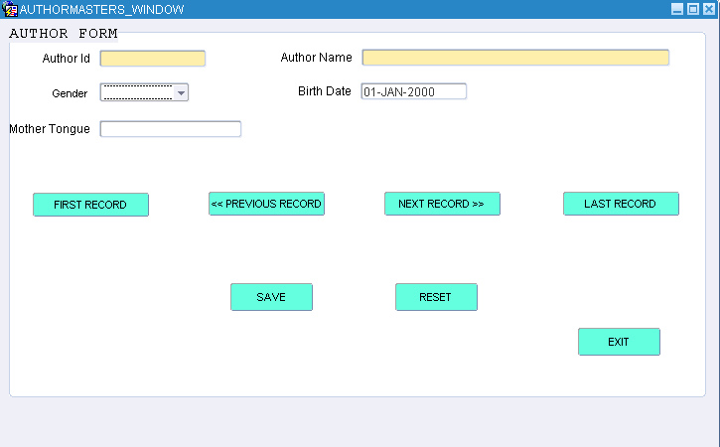

Book Master Form

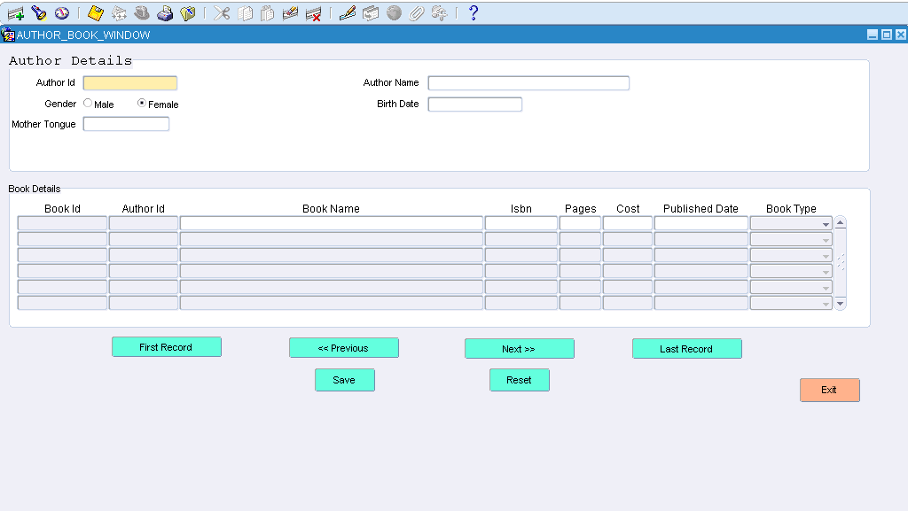

Book Database 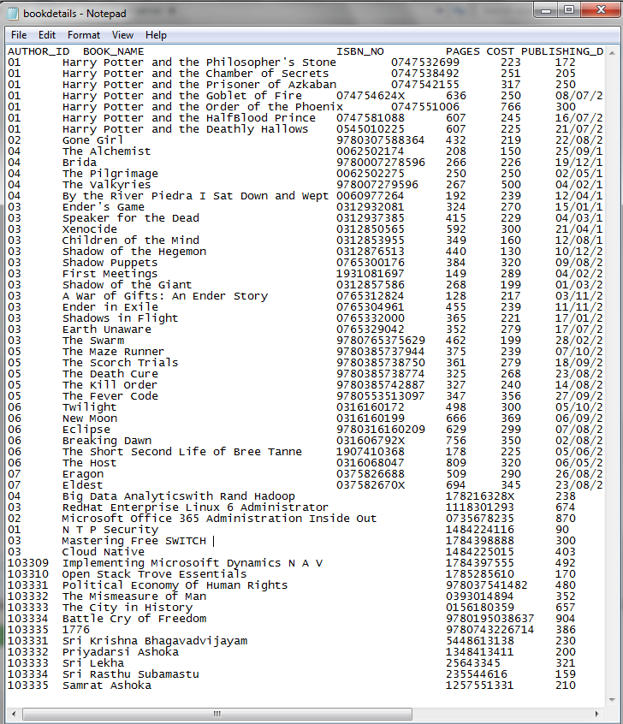

Book Control File

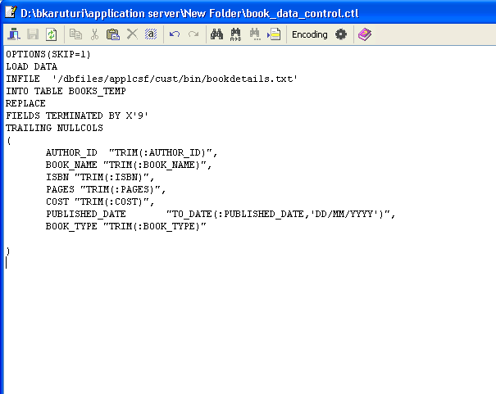

Author Data

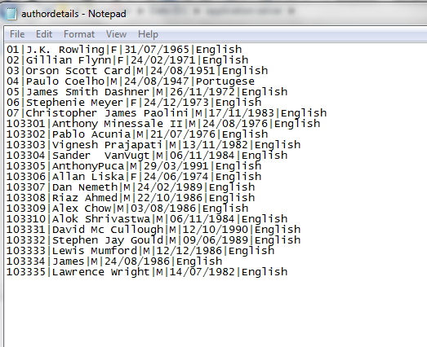

Author Control File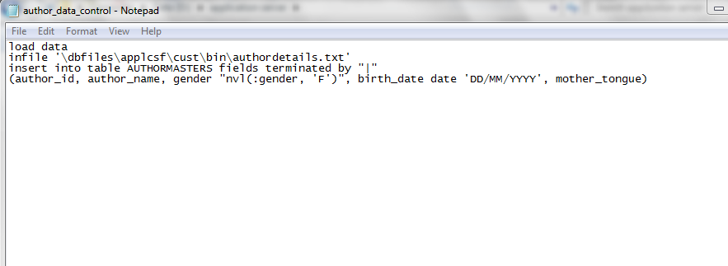

Report Data Model

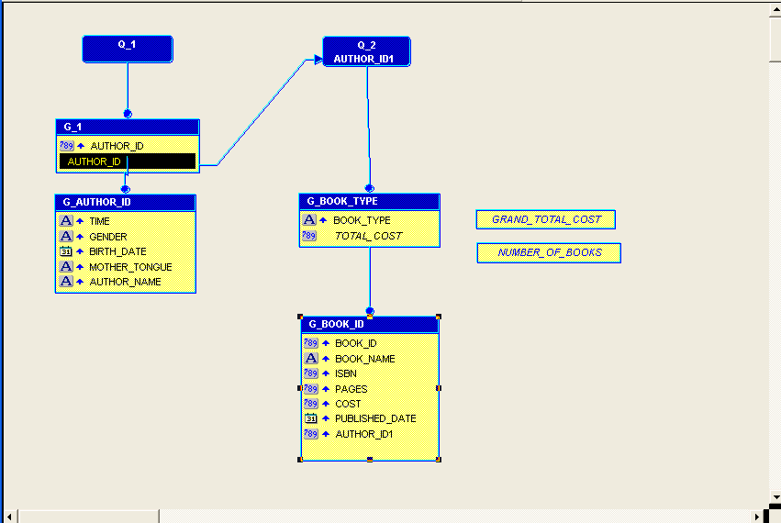

PAPER LAYOUT

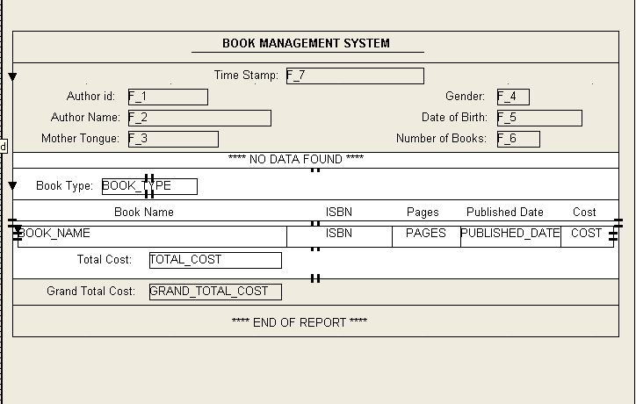

XML Generated File

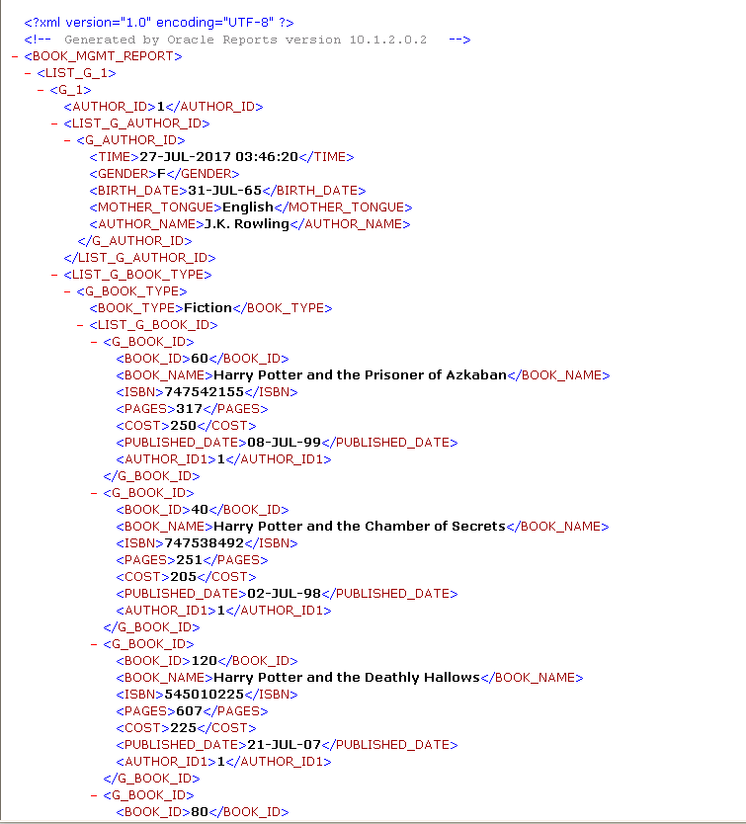

RTF File

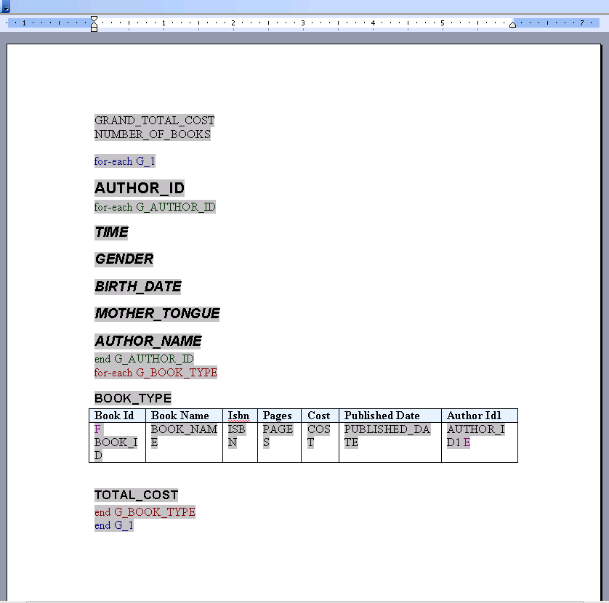

Generated Report For Output

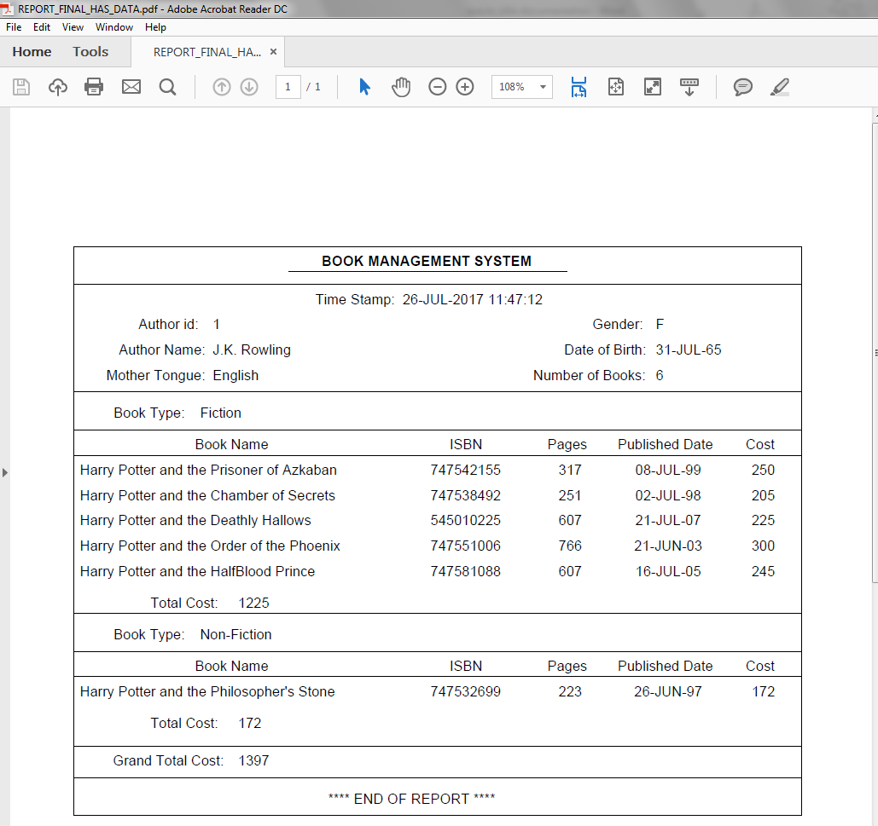

Generated Report For Output- No Data Found

